ELECTRICAL FEEDER CONNECTION PCB ASSEMBLY

- PARTS:

QUANTITY: PART #: NOMENCLATURE:

7 PER BOARD (14 PER MACHINE) 17463-1L HEADER, STR 10-PIN LONG LATCH

2 PER BOARD (4 PER MACHINE) 17543-3 HEADER, 3-PIN, METHODE

1 PER BOARD (2 PER MACHINE) 17675- TERMINAL STRIP, 3-TERMINALS, PCB MOUNT

1 PER BOARD (2 PER MACHINE) 217043- BLANK, PCB, ELECTRIC FEEDER, CONNECTION

- ASSEMBLY:

- PLACE TWO 17543-3 HEADERS IN THE RS-485 LOCATIONS AND SOLDER THEM IN PLACE, ACCORDING TO DIAGRAM 1.

- PLACE ONE TERMINAL STRIP IN THE APPROPRIATE LOCATION AND SOLDER IT IN PLACE, ACCORDING TO DIAGRAM 1.

- PULL PIN #3 OUT OF ALL SEVEN 17463-1L HEADERS.

- PLACE SEVEN 17463-1L HEADERS INTO THE APPROPRIATE LOCATIONS AND SOLDER THEM IN PLACE, ACCORDING TO DIAGRAM 1.

- CLEAN ALL BOARDS USING INHIBISOL™ SOLVENT.

NOTE 1
PIN 1 OF THE HEADER CAN BE FOUND BY LOOKING FOR THE ARROW ON THE

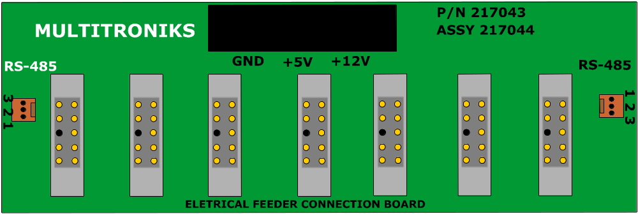OUTSIDE OF THE HEADER. PIN 1 WILL LINE-UP WITH THIS ARROW

Diagram 1

